- Birds view of the Two Networked Buildings
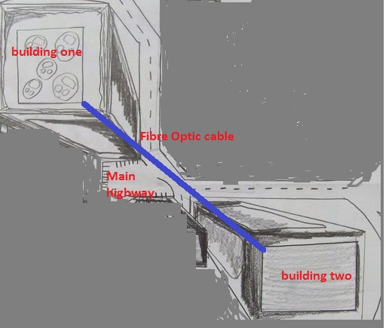

- General Network Floor Plan of The Two Buildings
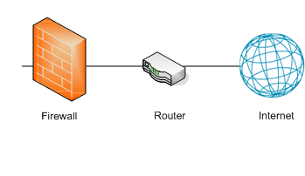

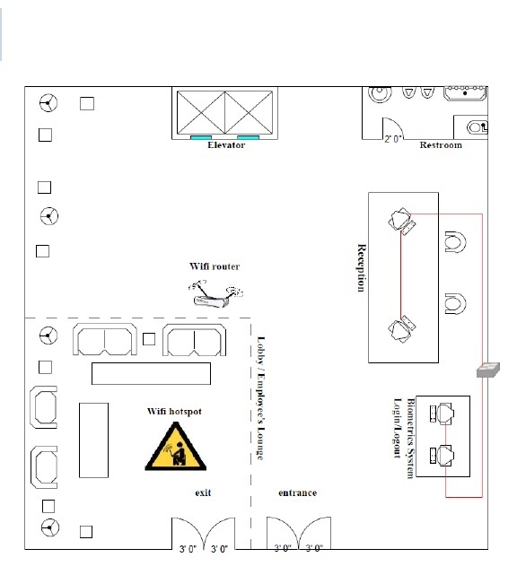

3.Building One First Floor Network Layout
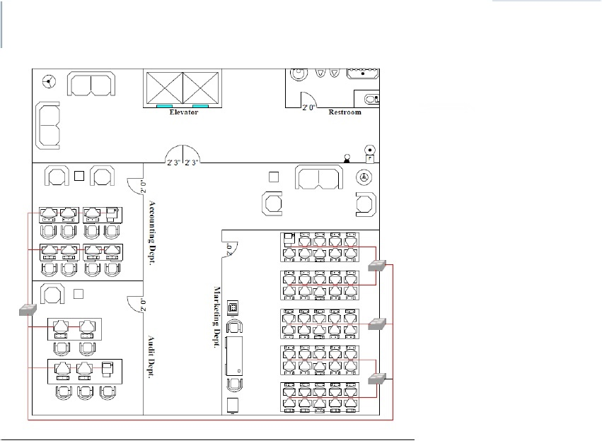
4.Building One Second Floor Network Layout
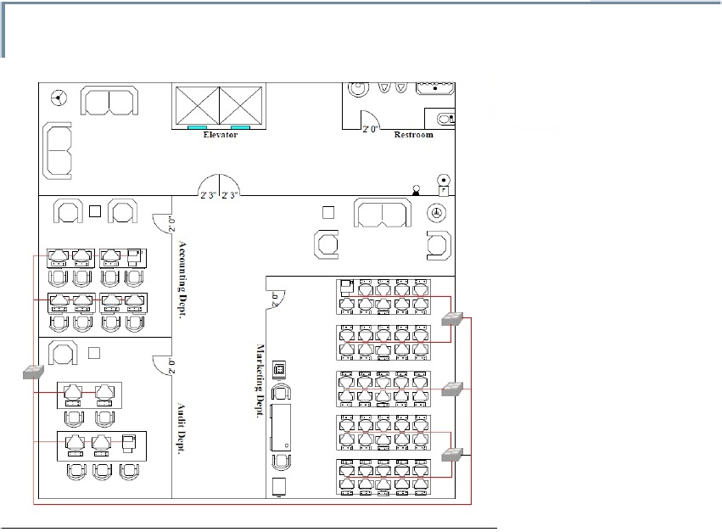

5.Building One Third Floor Network Layout
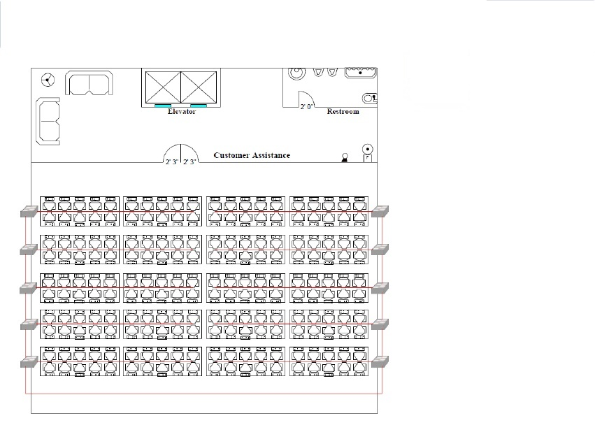

6.Building One Fourth Floor Network Layout
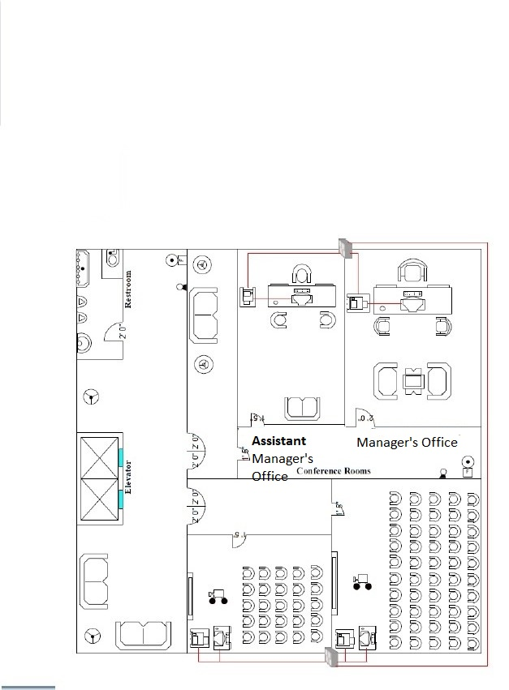

7.Building Two First Floor Network Layout
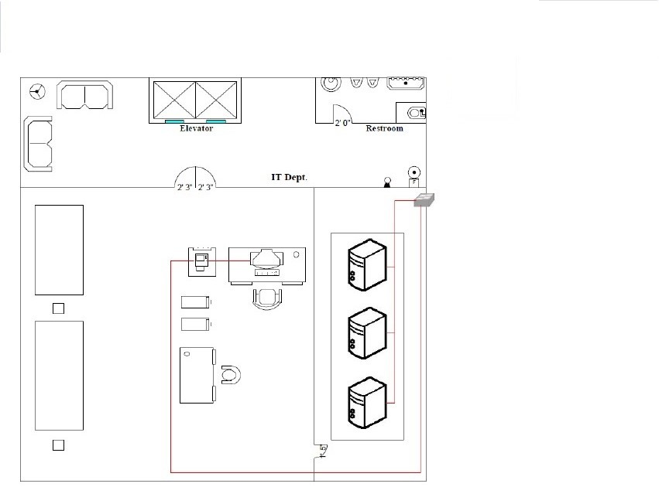

8.Building Two Second Floor Network Layout
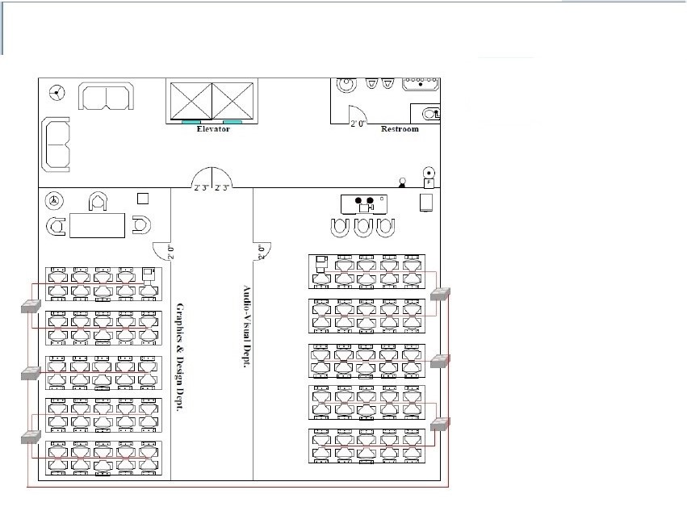

9.Building Two Third Floor Network Layout
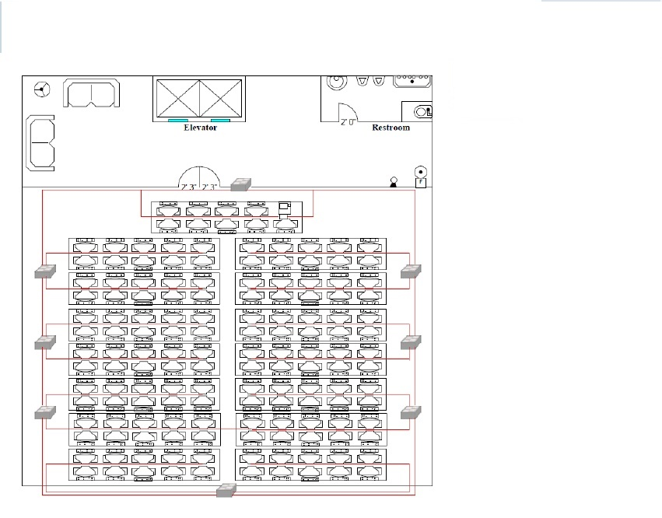

10.Building Two Fourth Floor Network Layout
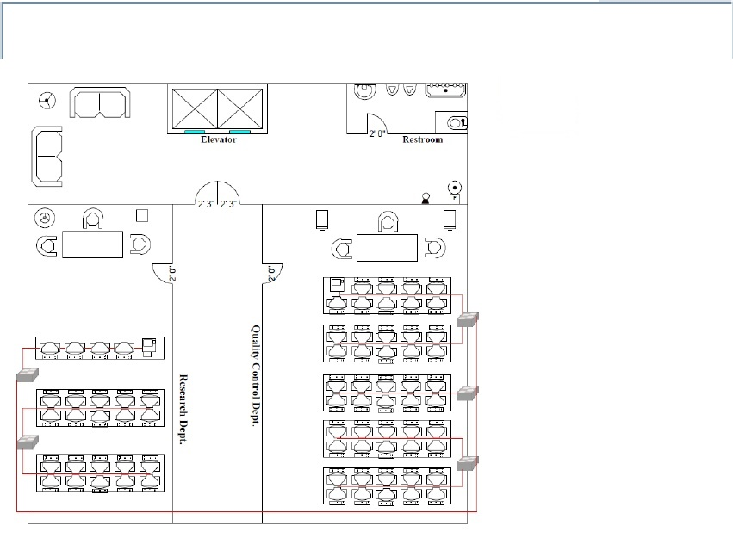

Key
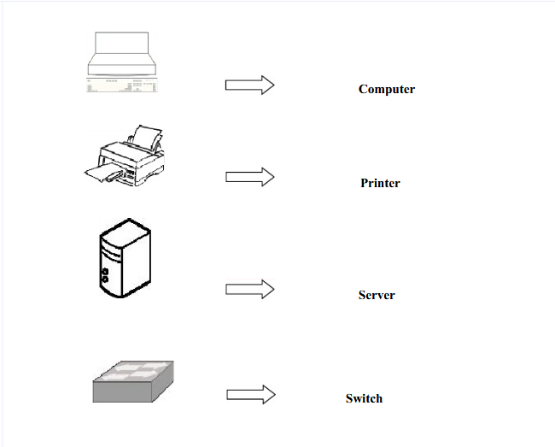
Description Of The Whole Network Layout
The structures are a 4-story building. Each floor comprises of at least one rooms. All computers in one room are associated with a switch. All changes are associated with one fundamental switch that is situated in the IT Department in the Floor. The switch in the IT room is associated with 3 servers. 1 will be the primary server, and the other is the move down server.
The biometric framework and the PCs in the gathering are associated with the same switch. There is likewise a parlor with wireless association in the first floor. The range can achieve all the area in the parlor. The wireless device is being associated with the switch in the IT division.
The firewall is connected to a router in the floor of each building where it links the LAN to the internet.
ISPs
The internet services will be provided by the local telecommunications companies for example (cite any local ISP from your state).
Network Backup.
The network has been implemented using mesh topology hence a failure in one computer will not affect other computers on the network.
There is a primary central server located in the IT department where shared documents are stored and secured for access by allowed devices.
Network backup providers that use secure cloud services are hired to store sensitive documents.
Cables used
All the devices on the network are connected to each other using shielded twisted pair cables.
The two buildings are connected to each other via fiber optic cable that runs from the top of one building to the top of the other.
Floor Assignment:
Building one (Customer Support Centre)
1st floor – There will be a secretary work area close to the passageway. It's for the request need of the guest that will visit the building. Biometric framework and the parlor with WiFi connection is situated in this room moreover. Biometrics
2nd floor - Training room and examination room is situated here. The two rooms have no entrance to the web. Since there is no requirement for the PC that is utilized for exam and training to utilize the internet.
3rd floor - Customer help is situated in this floor. This is the place the worker will assist customer and noting their worry about the company.
4th floor - Marketing apartment, review division and bookkeeping office is situated in this floor. These division should speak with each other regularly, that is the reason they are situated in a similar floor
Building two (IT Centre )
1stfloor - The IT room is situated here. The IT office is in charge of taking care of passwords, order preparing, item and administration questions, estimating data, framework transfers, and general inquiries.
2ndfloor - Audio visual division and realistic and outline office is situated here. These department should speak with each other regularly that is the reason they are located in a similar floor.
3rdfloor - Software wrapping research facility is situated in this floor. The area is close to the varying media, realistic and plan, and IT division since it has some comparative capacity so they can impart easily.
4th floor - Research division and quality control office is situated in this floor. The quality control division has no web association since this is where the employee will check their item and profitability. There is no requirement for the web.

